***HOW NATURE WORKS***

***FOOD CHAIN AND ENERGY FLOW***

All living things are made up of proteins, each with different roles in the organism. They form bones and muscles, release hormones, and powerful immune system responses, to name a few. Each protein comprises its own unique sequence of the same 20 amino acids that are found in all life on Earth. Our connection to Nature is embedded in the cells we are made of, in the resources we use to live, and even in the vibrations that come from our magnetic field.

Nature has amazing systems for providing constant sources of energy and nutrients, in a variety of forms, to support the many complex and diverse communities of thousands of species and their ecosystems.

When human activities interfere with Nature’s processes, it comes at a price. The Four Laws of Ecology (below) can help us to understand our true impact on the environment and help us make informed choices for the present and for future generations.

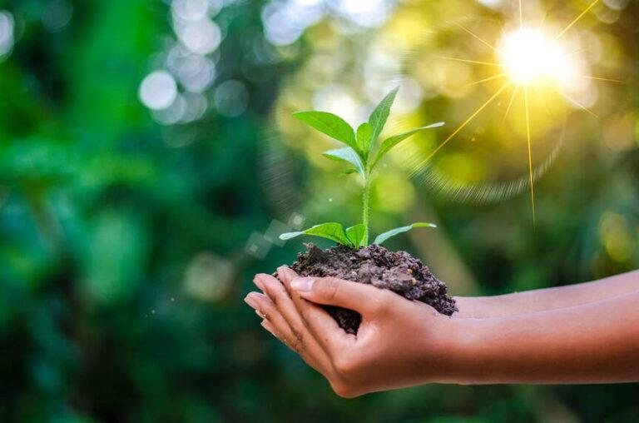

**THE FOUR LAWS OF ECOLOGY**

1. **Everything is connected to everything else**: Life relies on other life. Trees give us shelter from the weather, bees pollinate plants, and plants give us oxygen. The food we eat connects us to all four of earth’s systems: air, water, life, and land. Our food crops come from the environment, it’s grown in the soil where water and nutrients are provided, using carbon dioxide from the air and energy from the sun.

2. **Everything must go somewhere**: Waste doesn’t simply disappear. Waste created from one process will end up in another process. Oxygen is the waste product from plants when they create food during photosynthesis. It’s released back into the air and supports life that breathes oxygen.

3. **Nature knows best**: Everything in nature has a purpose and can be recycled into another form. Trying to improve or change the natural process always ends up having a negative effect. Adding fertilizers to make crops grow bigger and faster than nature intended can damage soil microbes and pollute waterways.

4. **There’s no such thing as a free meal**: Every resource we take from the environment has a cost attached. The burning of fossil fuels provides power and transport, but the waste products increase the temperature of the atmosphere and decrease air quality by adding harmful gases, which can enter the food chain.

***WHAT SHAPES AN ECOSYSTEM?***

An ecosystem is a community or group of living organisms that live in and interact with each other in a specific environment.

Two essential natural factors shape ecosystems:



Biotic factors are living organisms that include plants, animals, viruses, bacteria, and fungi.



Abiotic factors are the physical and chemical components that create the environment.

Abiotic factors include:

* Wind
* Elevation
* Moisture
* Currents
* Radiation
* Inorganic nutrients
* Temperature
* Climate
* Sunlight
* Water
* Water salinity
* Turbidity
* Landforms
* Latitude
* Minerals
* pH
* Soil
* Altitude
* Disturbances
* Pollution
* Precipitation
* Weather

Together, the biotic and abiotic factors make up an ecosystem. The biotic and abiotic elements depend upon and support each other through a variety of interactions. The constant cycling of nutrients and energy through the ecosystem is what creates a healthy and sustainable habitat that supports life.

Like humans, all living things have a tolerance to the conditions in their environment. This is why communities of living organisms can vary in different locations across the planet. In the Arctic, for example, animals have thicker fur.

Could a polar bear live in a tropical climate?

Species evolve and develop physical and behavioral characteristics that are adapted to the abiotic conditions of the environment in which they live. At the same time, they are also adapted to nourish and support their habitat. Interdependence is the key to the survival of animals and the ecosystems in which they live.

So, environmental factors influence where certain species can live, creating a community of different species suited to that particular environment. The species that inhabit a region consume, move, and recycle nutrients and energy to provide a constant source of nutrients and energy that are available for other species within the same ecosystem.

***ENERGY - THE SOURCE OF ALL THINGS***

All living things need nutrients in the forms of solids, liquids, or gas, as well as energy from the sun, to live. Nutrients that pass through the food chain go through trophic levels.

A trophic level is made up of a group of species that share the same link in the food chain, passing on essential nutrients and energy from one level of the pyramid to the next. The amount of energy and nutrients, that each trophic level passes along to the next, is illustrated in the pyramid in percentage.

Species in any given ecosystem support the transfer of nutrients and energy to species in the next trophic level in a form that they can consume, and so on. The energy and nutrients are then recycled back into the soil, creating a healthy, self-sustaining ecosystem.

Each level of the trophic pyramid represents a group of species categorized by the way they get their energy:asproducers, consumers, or decomposers.

When energy is consumed by an animal, most of it is used for movement and maintaining body temperature to keep them warm. In fact, only 10% of that energy is stored and passed on to the next link in the food chain. This means that animals in higher trophic levels must consume more nutrients and energy to sustain themselves.

Energy and nutrients move through terrestrial ecosystems and different trophic levels transfer nutrients to other levels.

***SOIL: THE FOUNDATION OF TERRESTRIAL ECOSYSTEMS***

Healthy soil is the foundation of any terrestrial ecosystem. It is where the first link in the food chain gets its nutrients from. Healthy soils are infused with a cocktail of organic carbon from fecal matter and decomposed plants or animals, oxygen, water, and minerals essential for life. These elements provide the perfect habitat for the first level of the food chain. Bacteria and fungi live in the soil as well. Their role will be explained later in the lesson.

Soils are the source of nutrients and energy for the living part of ecosystems. When plants establish in soil, they change its composition by adding more organic carbon and nutrients during photosynthesis. This increase in nutritious resources allows for more plants to establish in the soil, and in turn more animals can inhabit the area because there are enough resources for them.

Healthy soils have a huge impact on the ecosystem’s ability to store energy, water, and nutrients; the three basic resources that support life. The interactions between microorganisms (living things you can’t see by eye) and macroorganisms (living things you can see) move these resources into various forms to support a variety of different organisms.

Animals don’t all share the same diet; plants don’t have mouths to eat food as we do. So having resources in different forms supports a more diverse ecosystem.

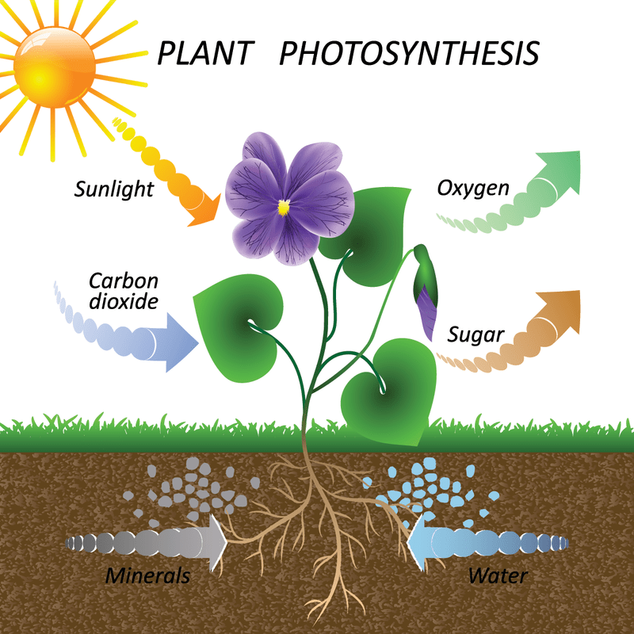

***THE FOOD CHAIN***

This is what a food chain illustration looks like:

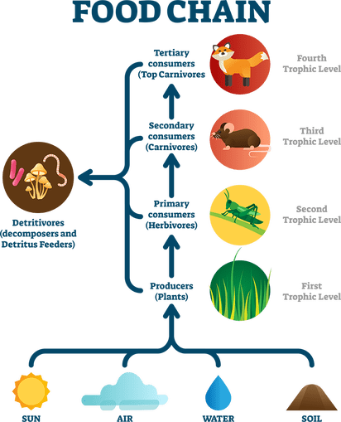

In ecology, the food chain illustrates how energy and nutrients are transferred from one living organism to another in the forms of food. The smallest organisms are fed upon by larger ones, which in turn feed still larger ones, and so on. The food chain is an elegant systematic arrangement that builds upon itself so that it can supply all living things with the amounts of energy that they need based on their sizes, activities, and lifestyles. In the end, the food chain becomes a cycle of life in which all energy sources break down to feed the earth, the cycle begins once again, and life continues. In the natural order things, this is how Mother Nature beautifully orchestrates the natural rhythms of self-sustaining ecosystems.

Below is each level of the food chain and how each functions:

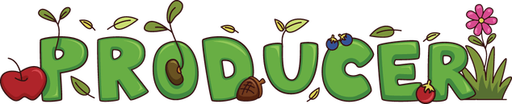

**Producers** are organisms that make their own food. In terrestrial food chains, they are plants, trees, bushes, grasses, and anything that has leaves. They are called autotrophs (from Greek, “auto” means “self” and “troph” means “feeding”) because they create energy by absorbing carbon dioxide from the air through their leaves and sucking up water and nutrients from the soil, with the help of fungi and bacteria. They use the sun’s energy to convert carbon dioxide into oxygen and water vapor that they then release through their leaves into the atmosphere. They are responsible for infusing energy into the food chain, making them the first link of the food chain. Without plants, all the other animals in the food chain would not exist.

Producers create energy in the forms of glucose (a form of sugar), amino acids, proteins, and fats, which they store inside new cells that are made using the nutrients (nitrogen, sulphur, and phosphate) they took from the soil. Those nutrients affect how fast plants grow.



Consumers cannot make their own food. They must consume other living things to obtain energy.  
Consumers are also called heterotrophs (from Greek, “hetero” means “other” and “troph” means “feeding”).

There are different types of consumers defined by the type of food that they need to consume to produce energy:

**Primary consumers** eat producers. They are the next link in the food chain.

Primary consumers are usually herbivores—animals that feed on plants. They can be as small as grasshoppers and hummingbirds or as large as deer and cows. They typically have multiple stomach chambers and complex digestive systems, including long intestinal tracts, which are designed to maximize the energy that they can absorb from the plants they consume. Herbivores are important energy sources for secondary consumers who benefit from the energy they produce and store inside their bodies.

**Secondary consumers** eat primary consumers, making them the next link in the food chain. Secondary consumers are divided into two categories:

* Carnivores—animal that feed on flesh. Their digestive systems do not efficiently or effectively process a plant-based diet. They have less complex digestive systems and shorter intestinal tracts than herbivores.
* Omnivores—animals, like humans, whose diet consists of both plants and animals. They can actually be both primary and secondary consumers because their digestive systems can process both plants and animals. This feeding strategy is a great advantage when food is scarce because omnivores benefit from the greatest variety of food sources.

**Tertiary consumers** are carnivores that feed on secondary consumers. They are usually larger in size and fewer in population than the consumers they eat. If a carnivore eats another carnivore, it will be a tertiary consumer or higher.

**Quaternary consumers** eat tertiary consumers. They are usually the last link in the food chain. They typically require a lot of food to meet their energetic needs either because of their size, like humans, or because of the way that they use energy. For example, cheetahs are not that large, but they need a lot of energy resources to run at speeds of up to 35 mph (56 km/h). Since they require a great deal of food, quaternary consumers can also be omnivores, feeding on producers and other consumers. They are typically apex predators that eat all the other levels of the food chain but are rarely ever preyed upon and eaten themselves.

Not every ecosystem has four trophic consumer levels. Some only have two or three. In rare instances there may be five. The more plant and animal species there are in an ecosystem, the more pathways there are for energy to move up the food chain, and the more trophic levels it can contain.

As energy and nutrients are consumed and stored along the food chain, they eventually need to be recycled back into the ecosystem. This occurs through defecation and death.

What animals occupy each consumer category?   
Why would they be placed in that category?

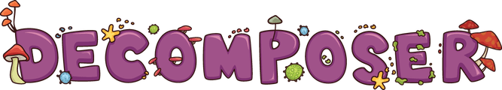

Decomposers are organisms that break down dead or decaying material. Decomposers are the final link that completes the cycle of life, returning nutrients to the soil for use by autotrophs. They work in stages.

The first stage of decomposition is carried out by detritivores—animals like worms and flies—that only feed on already dead and decaying animals or plants, breaking them down for the final stage of decomposition.

In the final stage of decomposition, bacteria and fungi change the structure of nutrients such as nitrogen, phosphorus, and carbon into a form that plants can absorb through their roots. These are called saprovores.

These saprovores are the bacteria and fungi that allow plants to take up the nutrients at the very start of the food chain. Unlike detritivores, they do not consume nutrients and energy. Instead, they break down nutrients by oozing enzymes from their bodies. These enzymes change the structure of the organisms into forms that can be absorbed by plants’ roots.

Without decomposers to complete the cycle, dead plant and animal matter would build up and important nutrients would remain locked inside. Soils would become nutrient-poor and unable to support primary producers sufficiently, having negative domino effect up the food chain.

***SUMMARY  
ENERGY FLOW THROUGH THE FOOD CHAIN***

* Producers use energy from the sun and the resources in the soil to create their own energy and are the source of all energy brought into the food chain.
* Herbivores consume plant matter and store the excess energy in their cells. Energy that is not available to carnivores, because they are unable to effectively digest plant matter, is transferred into animal cells, a form they can process.
* When animals die, decomposers break down the dead and decaying organic matter into smaller forms until the microbial community in the soil breaks them down into basic nutrients again. The plants absorb them again, thus continuing the cycle of energy and nutrients.
* Each trophic level supports the next. To keep an ecosystem sustainable, the nutrients and energy taken from it must be returned. Otherwise, producers do not have the necessary resources to create more energy.

Nature keeps the ecosystem healthy by constantly cycling energy and nutrients through the food chain.